KAHUNA RESEARCH GROUP
RESEARCH CENTER

P.O. Box 659 | Captain Cook, Hawaii 96704

Phone 1(808)238-2264
E-mail: director@kahunaresearchgroup.org

* * * * *

The Kahuna Research Group Research Center collects accounts of people’s religious, spiritual and paranormal experiences, which are kept in our Archive. The reports are transferred to a database in an anonymous form for ease of access for researchers and to protect confidentiality. Some details about you and your experience will be very helpful, to give authenticity to and to enhance our research.

We thank you for being willing to share the details of your experience with us.

On the following page is a form for you to complete. You are welcome to return it by email, remembering of course that email is not as private as regular mail. If you would prefer to return the form by post, you are most welcome. Our mailing address is on this form.

If you choose to reply by email, you may type your name at the bottom of the page and that will count as a signature.

* * * * *

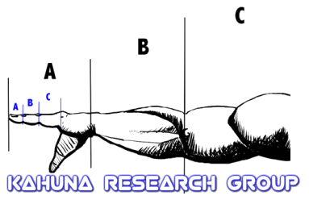

Religious, Spiritual or Paranormal Experiences

collected for

The Kahuna Research Group Research Center

Director of Research: Zach Royer, C.L.P.I., O.M.

CONFIDENTIAL DETAILS

To accompany archived Religious, Spiritual or Paranormal Experiences

given to the Kahuna Research Group Research Center.

We are very grateful to receive the account of your experience for our archive. Please be good enough to complete this form, remembering to sign and date it. Your details are kept confidential: we need them because it is important that we can prove all accounts of experiences are genuine.

Name |  |  | Title
Address  Postcode | Phone Number  E-mail address
Country | Male / Female
Date of birth | Date of your Experience
Date of Writing to us | Age at time of Experience
Religious Background | Geographical Location at time of Experience
Occupation | Academic or Vocational Qualifications
Would you be happy for researchers to contact you? Yes( ) No( )
(please mark “x” as appropriate)

We would be most grateful if, to assist research, you would agree for this account of your experience to be recorded, in an anonymous form, on our database, located at the Kahuna Research Group Research Center and also available online to accredited researchers. |  | Database Yes ( ) No ( )
What was your experience? How did it feel?
(If you have already sent us an account of your experience there is no need to complete this section)

This box will expand as you type
Please tell us something about the ‘fruits of the experience’.
(e.g. What did it prompt you to do or think? Did it influence any decisions you were making?
Did it cause you to change the way you lived your life? etc.)

This box will expand as you type
What do you think caused the experience?

This box will expand as you type
How did people react when you told them about the experience?
(e.g. friends, family, religious and medical professionals)

This box will expand as you type
Your signature | Date
Many thanks . Please return form to:  Zach Royer  Kahuna Research Group Research Center  P.O. Box 659  Captain Cook, HI 96704  Email: director@KahunaResearchGroup.org | For Office use:  Record number  Input by  Date

When the questionnaire is used on-line, the boxes will expand, so you can type in as many pages as you want.

If you download or copy the form (and don’t complete it online) please continue any section on a separate sheet of paper.

